

**J.D. Systems**

Technology Center Newsletter Issue 11

**Safety Tips – Browsing the Web**

afe web browsing is not only important in the workplace, but also in your personal use. In this

S

month’s safety section, various safe browsing techniques will be discussed.

Browsing the web resembles crossing a busy street: you need to exercise caution and look carefully for unexpected traffic. Cybercriminals are on the lookout to prey upon unsuspecting users, so you should follow these guidelines when browsing:



Verify the website is safe.

Browse anonymously.

Clear your browsing history.

Enable a pop-up blocker.

Use a phishing filter.

Verify the website is safe. Type the website address of your email, banking, social networking, and other personal accounts directly in a browser; never visit these websites by tapping or clicking links found in email messages. Before you sign in, double- check the web address to verify that it is correct. Most browsers change the color of the address bar to verify the website is legitimate. Also, check that the web address begins with https instead of the less secure http, and look for a closed padlock symbol beside it.

Clear your browsing history. A copy of every website you visit is stored in the browser’s cache folder. If you perform online banking or view your credit card transactions, the cache could contain personal information such as passwords and account

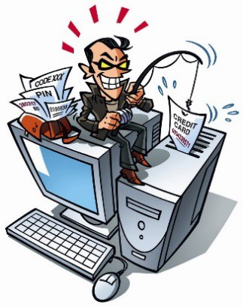numbers. You can specify to clear cache automatically each time you close a browser.

Use a phishing filter. Phishing is a scam in which a perpetrator may attempt to obtain your personal and financial data and

information. Many browsers include a phishing filter, or a program that can warn or block you from potentially fraudulent and/or suspect websites.

Enable a pop-up blocker. Malicious software creators can develop a pop-up ad, which is an Internet advertisement that suddenly appears in a new window on top of a webpage that is displayed in a browser. A pop-up blocker is a filtering program that is designed to stop pop-up ads from displaying on webpages. Many browsers include a popup blocker. You also can download pop-up blockers from the web at no cost.

Browse anonymously. To protect your online identity, you should use a proxy server, which is another computer that screens all of your incoming and outgoing email and other messages. The proxy server will prevent your browsing history, passwords, user names, and other personal and confidential information from being revealed.